

**Date: Sunday 19th July**

**Event includes an optional overnight stay and drive home Monday.**

**Yulefest Lunch – with all the festive trimmings including Bon Bons**

**Menu: 4 Course meal, Entrée Main, Dessert, c/w Tea, Coffee & Christmas cake. Includes complimentary glass of Gluhwein.**

**Resident Pianist & Singalongs**

**Lucky Door Prize**

**Venue: Carrington Hotel, 15 – 47 Katoomba St, Katoomba**

**Time: 12.00 Noon**

**Cost: $63 per head**

**Bookings essential : RSVP 10.7.20**

**Payment to TSOA : BSB: 032-081**

**A/c 910909**

**Contact: Geoff Batty**

**Email:** [**geoffrbatty@gmail.com**](mailto:geoffrbatty@gmail.com)

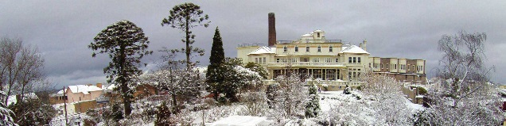**Mob: 0428 242 597**

**TSOA NSW**

**Christmas in July**

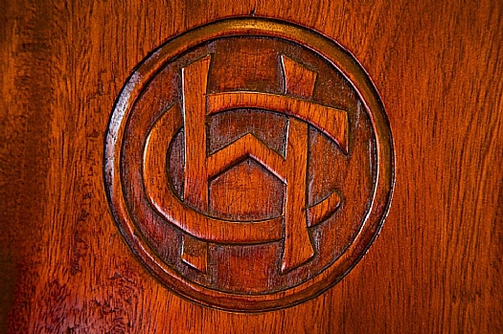

[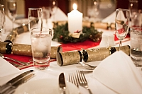](https://www.thecarrington.com.au/imagesDB/gallery/Yulefest_11copy.jpg)