 Windyridge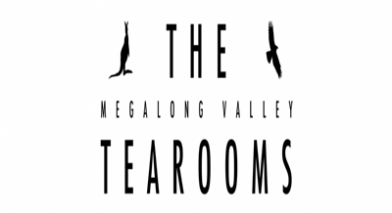

TSOA Social Run

Date: Sunday 5th April 2020

Ladies Day – Blue Mountains

Meet: M4 Service Centre, Red Rooster Car Park.

Time: 8.30 for 9.00 Departure

10.30 Windyridge Gardens

Cost: $10 per adult (Tea & Coffee incl in admission)

25 Queens Ave, Mt Wilson 2786

12.30 Megalong Valley Tea Rooms

824 Megalong Valley Rd, Megalong. 2785

 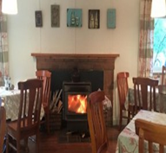

RSVP: 27th March 2020

Ladies & Gentlemen, please prepare yourselves & vehicles for a fun day in the mountains.

[](https://pixabay.com/vectors/alice-in-wonderland-tea-party-276452/)

Geoff Batty Mob: 0428 242 597 Email: [geoffrbatty@gmail.com](mailto:geoffrbatty@gmail.com)