

[](http://infobluemountains.net/locodepot/) 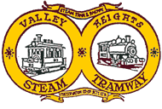

Valley Heights Locomotive Depot Heritage Museum

Sunday 8th March 2020

17 Tusculum Dve, Valley Heights 2777

Meet 9.15 am Red Rooster, M4 Service Centre, Eastern Creek for 9.30 depart

Arrive 10.00 at Museum

Steam Train Rides, Museum Open Day, Model Railways

<http://infobluemountains.net/locodepot/>

Lunch: 12.30

The Gather,

Springwood Sports Club

83 Macquarie Rd Springwood. 2777

https://www.springwoodsports.com.au

[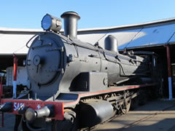](http://infobluemountains.net/locodepot/exhibits-large-5461.shtml)

[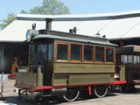](http://infobluemountains.net/locodepot/exhibits-large-tram103a.shtml)

Contact: Geoff Batty

Email: [geoffrbatty@gmail.com](mailto:geoffrbatty@gmail.com)

Mob: 0428 242 597