COFFEE & CAKE JULY
For those that are getting tired of Nescafe we will be resuming our coffee& cake schedules starting 29th July at Vanilla Cream Annangrove . The old Amaroo Park raceway venue .
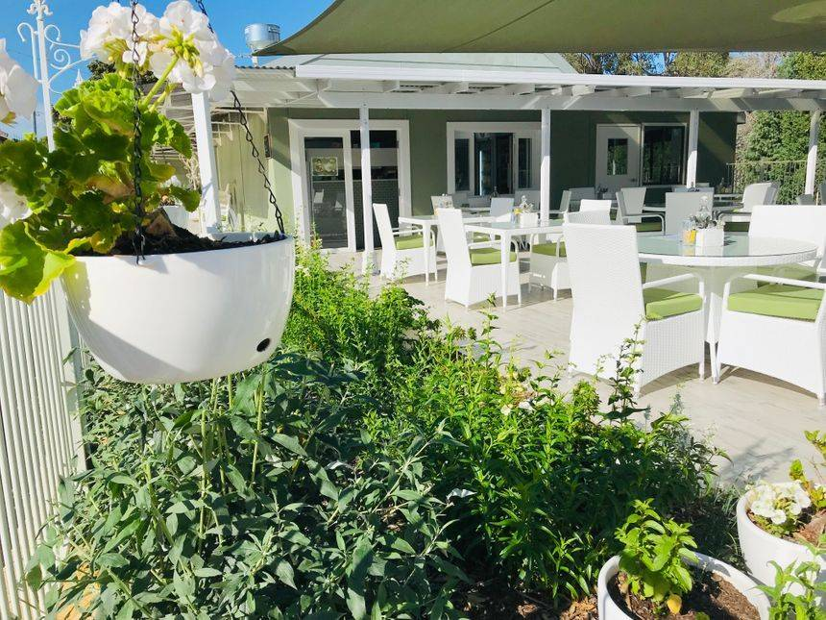
You must email or text me with your intention to come as numbers for bookings is essential.
Email info@aodaustralia.com or 0409656577
See you all there Keith and Merran

